Session – 1

Google Ads: The Fundamentals

Segment - 1

Module Overview

Think about the last time you searched for something online. Maybe you looked up 'best running shoes' or searched for 'weekend getaways near me'. Within seconds, you saw ads that felt tailor-made for you.

Today’s consumers no longer follow a straight path; they browse, compare and explore across platforms. The challenge is to reach them at the right moment with the right message.

That is where the Google Ads platform makes a difference. It gives advertisers the edge to stay ahead by connecting with audiences where it matters most.

Welcome to the module titled 'Google Ads', where we will uncover how this platform powers full-funnel marketing, from search intent to Demand Generation (also called Demand Gen).

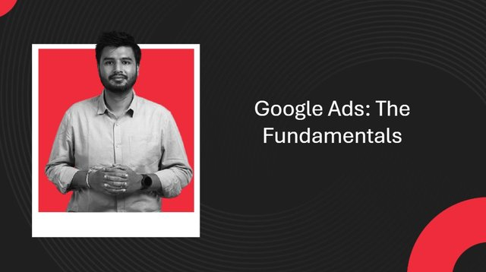

By the end of this module, you should be able to:
- Explain the core fundamentals of Google Ads
- Produce Search campaigns to capture user intent
- Create Demand Gen campaigns for growth and performance
- Measure success using data, metrics and attribution
Let’s begin the first session of this module, in which we explore the key fundamentals of Google Ads. This includes its objectives, structure and place in the digital ecosystem, i.e., the aspects of 'what, why, how and where' of Google Ads. We will also discuss the fundamentals of Search Ads, the cornerstone for all search-focused advertising solutions.

Guidelines for graded questions

Note that graded questions are given on a separate page labelled 'Graded Assessments' at the end of the module. These graded questions will adhere to the following guidelines.

 | First Attempt Marks | Second Attempt Marks
Question With 2 Attempts | 100% | 50%
Question With 1 Attempt | 100% | 0

People you will hear from in this session.
Kaushik Sen Deka
Kaushik Sen Deka is a seasoned marketing strategist with deep expertise across the digital customer journey. At Google, he empowers emerging brands in EMEA to scale their businesses through impactful Google Ads strategies. With prior experience at ACKO Insurance and CleverTap, he has driven customer retention and enhanced CLTV through data-led marketing. A MICA alumnus with an MBA in Strategic Marketing & Communications, Kaushik brings a unique blend of analytical rigour and creative storytelling to modern marketing.

Throughout the session, you will be learning via multiple videos across segments. If required, please refer to the transcription document given below for a hassle-free learning experience.

Disclaimer 1: Throughout this course, you will see examples of different brands and institutes. These have been chosen from specific cases in a manner that would aid in demonstrating concepts. These do not reflect the current performance of any company. Any opinion expressed is strictly for educational purposes.

Disclaimer 2: The learning module may contain images, both still and moving, including photographs, advertisements, trademarks, video clips, etc., procured from the public domain, social media, or other print or digital publications, under Fair Use in accordance with Section 52 of the Indian Copyright Act, 1957, that are being used for the purpose of commenting, imparting education, disseminating information, illustrating an academic concept, teaching and research. All rights and credit go directly to their rightful owner(s). No copyright infringement is intended.

Disclaimer 3: upGrad does not endorse or advocate the use of any product/service covered in this session. The examples are solely for illustrative purposes.

Disclaimer 4: Please note that the platforms’ interface and content trends are subject to certain updates; hence, the images and videos might differ from the actual ones. However, the understanding of the process remains the same.

Notes from the video:

MODULE MAPPING
Reporting, attribution and key success metrics
Demand generation & performance
Mastering Search Campaign
Fundamentals of Search Ads
Google Ads: What, Why, How and Where?
Campaign Measurement
Demand Campaign Generations

